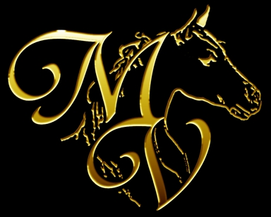 | MOUNTAIN VALLEY  Candace Oakes  Site 4 Box 2 RR 1  Millarville, AB T0L 1K0  Canada  403-620-3247  mvpaintsarabians@gmail.com | 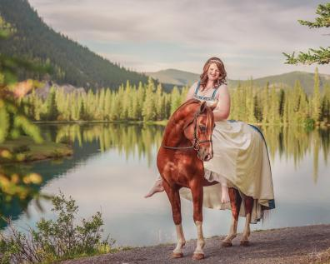

STALLION SERVICE CONTRACT

This contract is for the season of ___2021____ made and entered into between Mountain Valley, herein after designated Stallion Owner and
Name: ____________________________
Address: __________________________
City/State/Zip: ______________________
County: ___________________________
First Phone: ________________________
Email: _____________________________
(Herein designated Mare Owner)

For the following stallion, herein designated as Stallion:

Stallion’s Registered Name: MV LUKKHE FLASH Reg#: 47693
Registered with: CAHR Breed: ARABIAN Color: CHESTNUT
Sire Name: ___MY LUKKHE STARR___ Dam Name: ___MATTAFIRE___
CA, LFS & OAAM CLEAR – SCID CARRIER

To be bred to the following mare, herein designated as Mare:

Mare's Registered Name: _______________________________ Reg#: ____________
Horse’s Barn Name: _____________________ Registered with: _______________
Breed: ______________ Color: _______________ Foaling Date: __________________
Sire Name: _________________________ Dam Name: _________________________
Maiden ( ) Foal at Side ( ) Previous Foaling Years: ______________
Your Vet’s Name, address and phone #_____________________________________________
What is the anticipated time of first breeding? (circle)
February March April May June July

ARABIAN MARES MUST BE TESTED SCID CLEAR

*Copy of mare’s registration papers, copy of purchase agreement (if applicable), copy of lease agreement (if applicable) and SCID test results (if applicable) must be attached to validate contract.*

BREEDING FEE:
Shipping fees and collection fees must be paid by the Mare Owner before semen is shipped.
Breeding fee for 2021 is $600.00 CAD and is payable as follows.
• A non -refundable breeding deposit of $20O.00 CAD shall be paid at the signing
of this contract.
• The balance of $400.00 CAD will be paid in full prior to semen being shipped.
• Stud fee includes a LIVE FOAL GAURENTEE and a BREED BACK INCENTIVE.

SHIPPED SEMEN:
Shipping and handling fees are due in advance. Semen will not be shipped if fee is not
paid.
The Stallion Owner warrants that at the time of shipment the semen will be checked by the
veterinarian for viability. The Stallion Owner is not responsible for the untimely delivery or condition of the cooled-shipped semen once shipped.

SHIPPING COSTS:
All shipping and collection costs are payable by the Mare Owner directly to the veterinary
clinic that handles the collection. Moore Equine is the clinic currently used for collection and shipping. The veterinary clinic handles the shipping in Canada and in the US. Collection costs are currently $285.00 plus shipping and container. Prices subject to change.

BREEDING:
This contract is for one shipment of cooled semen to be sent to the Mare Owner. If another
shipment is required, the Mare Owner will be charged a $100.00 handling fee plus shipping
costs. If after a breeding attempt of 3 cycles a pregnancy has not been achieved, the
CLIENT may:
1. Continue breeding (Mare Owner will be charged $150.00 handling fee each time)
2. Substitute an approved mare and continue breeding (CLIENT will be charged $150.00 handling fee)
3. Choose to carry the breeding over to the following year. (a $200.00 handling fee will be charged)

BREED BACK INCENTIVE: Stud owner agrees to breed mare back the following season for 75% of that breeding season’s listed stud fee. Booking fee of $250 will be taken out of the reduced stud fee, and all normal charges (board, veterinary expenses, etc.) still apply and will be the responsibility of the mare owner. Not available in the case of twins.
AVAILABILITY OF STALLION: MV LUKKHE FLASH is generally available for breeding from February 1st to August 1st, though Stallion Owner will attempt to honor requests outside that time frame according to their schedule. Working on having Frozen semen available year round. Mare Owner understands that if stallion is away at a competition when breeding is requested then frozen semen, if available, may be shipped instead. .
CONDITION OF MARE: The Mare owner(s) agree(s) that the mare is in good healthy, is sound breeding condition and is up to date on all vaccinations and deworming.

SUBSTITUTION: If the mare does not get in foal, dies or becomes unfit for breeding, another mare may be substituted but only with the prior written consent and approval of Stallion Owner. It is agreed that if the stallion dies or becomes unfit for service then frozen semen, if available, will be used instead and Mare Owner will be subject to all applicable fees of handling and shipping said frozen semen. If no frozen semen is available and the stud fee has been paid in its entirety and no fresh semen has been shipped or mare has not been bred, then the stud fee minus booking fee shall be returned to the Mare Owner. Under no circumstances may the service be sold to another party unless prior arrangements have been made with the owner of the stallion. .
REGISTRATION: Stallion owner agrees to provide a breeding certificate to the Mare Owner and sign all necessary documents to register the foal, provided the Mare Owner has met the conditions of this contract. All fees to have mare approved for breeding with any registry and/or have foal inspected or registered is the responsibility of the Mare Owner. In the event of twins Stallion Owner will provide registration document for both foals. If mare loses the pregnancy/foal(s) due to the presence of twins when Mare Owner has chosen not to ultrasound for the presence of twins or chosen not to terminate one of the fetus’, the Live Foal Guarantee is Null and Void. The Stallion owner will rebreed the mare for 75% of listed stud service if both twins do not survive, although no additional stud fee will be charged if the twins do survive.

I have read, understand and agree to the above:
SIGNED:

Signature of Mare Owner/Leasee: _________________________________
My signature on this document signifies my agreement with all terms outlined above.
Dated: _________________________

Signature of Stallion Owner: __________________________________
My signature on this document signifies my agreement with all terms outlined above.
Dated: _________________________

